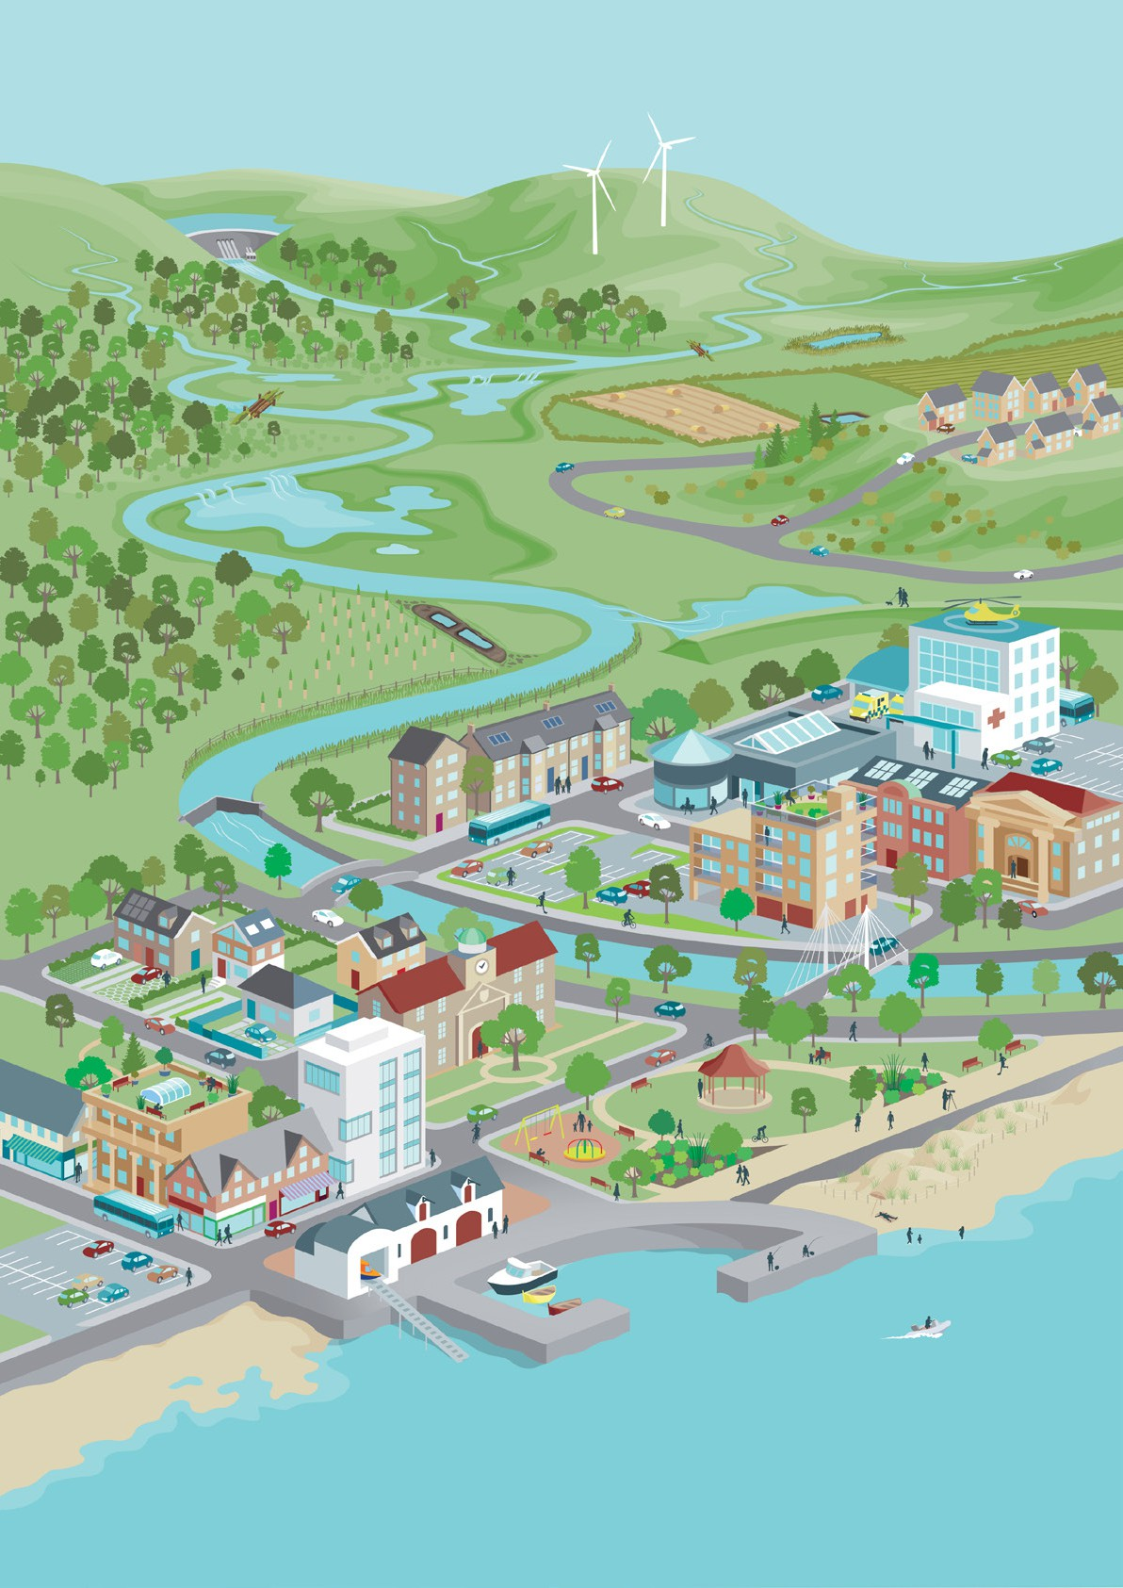

Flood Risk Management Plan

Shetland Local Plan District

Publication date: 22 December 2021

**Terms and conditions Ownership:**

All intellectual property rights for Flood Risk Management Plan is owned by SEPA or its licensors. The Flood Risk Management Plan cannot be used for or related to any commercial, business or other income generating purpose or activity, nor by value added resellers. You must not copy, assign, transfer, distribute, modify, create derived products or reverse engineer the Flood Risk Management Plan in any way except where previously agreed with SEPA. Your use of the Flood Risk Management Plan must not be detrimental to SEPA, its activities or the environment.

**Warranties and Indemnities:**

All reasonable effort has been made to ensure that the Flood Risk Management Plan is accurate for their intended purpose, no warranty is given by SEPA in this regard. Whilst all reasonable effort has been made to ensure that the Flood Risk Management Plan is up to date, complete and accurate at the time of publication, no guarantee is given in this regard and ultimate responsibility lies with you to validate any information given. SEPA will not be responsible if the information contained in the Flood Risk Management Plan is misinterpreted or misused by you.

**Copyright and acknowledgements:**

Full copyright and acknowledgements is available in Annex 3.

**Data Protection:**

You agree not to use the Flood Risk Management Plan in any way that constitutes a breach of the Data Protection Legislation including the General Data Protection Regulation and the Data Protection Act 2018.

**No Partnership or Agency:**

Nothing in these Terms and Conditions are intended to, or shall be deemed to, establish any partnership or joint venture between you and SEPA.

**No Interference:**

Nothing within these Terms and Conditions interferes with the statutory rights or obligations of you or SEPA.

**Jurisdiction:**

These Terms and Conditions are governed by Scots law and in the event of any dispute you agree to submit to the exclusive jurisdiction of the Scottish Courts.

For information on accessing this document in an alternative format or language please either contact SEPA by telephone on 03000 99 66 99 or by email at [equalities@sepa.org.uk](mailto:equalities@sepa.org.uk)

If you are a user of British Sign Language (BSL) the Contact Scotland BSL service gives you access to an online interpreter enabling you to communicate with us using sign language.

<http://contactscotland-bsl.org/>

Please refer to  [frequently asked questions](https://www2.sepa.org.uk/frmplans/documents/frequently-asked-questions.pdf) for up-to-date contact details.

If you would like to contact us in writing, please mark any correspondence for the attention of FRM Planning and send to:

Scottish Environment Protection Agency Angus Smith Building

6 Parklands Avenue Eurocentral Holytown

North Lanarkshire ML1 4WQ

This document has been produced in collaboration with:

|  |  |
| --- | --- |
|  | Scottish water logo |

**Foreword**

As we watch the news on TV or scan video clips on social media, we see much more regular violent weather. Bushfires of unprecedented size, ferocity and frequency happening in fire prone parts of the world and now happening where they were uncommon such as Siberia. Cyclones, tornadoes, heatwaves, droughts and, of course, as most affects Scotland - floods.

Anyone who has been in a flood area knows the intimidating terror it can bring. The foreboding that comes as people confront the potential damage or destruction of homes, businesses and other properties as well as injuries and, in the worst cases, loss of life.

This is all being made worse by the Climate Emergency. The recent COP26 meeting in Glasgow brought the world together to agree actions to do two things:

1. Reduce the emission of the greenhouse gases driving climate change, and
2. Help us adapt to the level of climate change that, despite our best efforts, is occurring.

The publication of this flood risk management plan is one of SEPA’s key actions to help Scotland with this second aim.

As a society, we need to take action to manage the risk of flooding and its impacts on our lives, recognising that the risk can’t ever be removed entirely. This plan takes our knowledge and understanding of flooding and the impacts of climate change and turns it into a set of actions that are planned, prioritised and co-ordinated to tackle flooding in the communities where it affects us the most.

Across Scotland, we now estimate that there are around 284,000 homes and businesses at risk of flooding. Our latest analysis shows that this could increase by around a further 110,000 homes and businesses if little or no action is taken to tackle climate change. Let’s look at just one area of Scotland for an example of the local impact. Within the Shetland Local Plan District it is estimated there are around 230 homes and businesses at risk from flooding, and this may increase to 300 homes and businesses by the 2080s due to climate change. All up, in this part of Scotland, there is a risk of river, surface water and coastal flooding and the expected annual cost of flooding is around £650,000.

#### So given the assessment undertaken, this plan:

* + Describes the ambition for managing flooding and the priorities for action that we believe are most important and helps inform the development of local plans. A local flood risk management plan co-ordinated by Shetland Islands Council, provides additional detail on the responsibility for delivery, funding and coordination of actions across the Local Plan District. Taken together, these documents describe the commitment of responsible authorities to address flooding.
  + Is published by SEPA and has been approved by Scottish Ministers. SEPA is just one organisation in the collective effort to manage flooding and this plan has been produced with the support and collaboration of Shetland Islands Council, Scottish Water and others with an interest in flood management. SEPA has taken account of the views received through a public consultation carried out during the development of the plan.
  + Is based on the fact that how we plan for and manage our flood risk has far reaching consequences for Scotland’s communities. The plans set the national direction of future flood risk management, helping to target investment and coordinate actions across public bodies. They explain what causes flooding in high-risk areas as well as the impacts when flooding does occur. This information is used as a basis for better decision-making across flood risk management organisations.

A lot of people, inside and outside SEPA, have contributed to the development of this plan. It underpins important decisions that will be made to protect people and property in Scotland from flooding and I hope that you find it valuable and useful.



Terry A’Hearn Chief Executive

# Contents

**Section 1: Flood risk management in Scotland**

|  |  |
| --- | --- |
| * 1. What is a flood risk management plan? …...........................   2. Managing flooding in Scotland ………………………………..   3. How the flood risk management plans were developed …... | 1  2  9 |
| * 1. Links with other plans and policies …………………………... 15   2. Next steps and monitoring progress …………………………. 17   3. Supporting information ………………………………………... 19   **Section 2: Shetland Local Plan District** | |

* 1. Overview of flood risk …………………………………………. 22
  2. Actions across the Local Plan District ….............................. 23
  3. Potentially vulnerable areas ………………………………….. 31

**Annexes**

|  |  |  |  |
| --- | --- | --- | --- |
| A1  A2 | Costs of actions …................................................................  Flood risk management plans consultation summary ……... | | 50  51 |
| A3 | Acknowledgements ……………………………………………. | 56 | |

# Section 1: Flood risk management in Scotland

**1.1 What is a flood risk management plan?**

Flood risk management plans are Scotland’s route map for reducing the effects of flooding on our communities. This is key to Scotland’s health, well-being and economic success.

They are also important in our response to the climate emergency as flooding is increasing due to climate change.

Flood risk management plans have been designed to ensure effort to reduce flood risk in Scotland is coordinated. Many organisations are responsible for flood risk management and the plans focus the work of these organisations to where the risk of flooding and benefits of action are greatest. The roles and responsibilities of some of the key organisations involved are set out later in this plan.

There is a plan for each of the 14 flood risk management districts in Scotland, which are called Local Plan Districts. These plans set out the long term ambition for flood risk management. They set objectives for tackling flooding in high risk areas and identify the actions needed to work towards those objectives. These are agreed by the responsible authorities and are based on the best available evidence on the causes and consequences of flooding. The actions are described and prioritised in 6 year planning cycles.

These plans complement the separate local flood risk management plans published in 2022. The local flood risk management plans explain in more detail how the actions set out in this plan for 2022 to 2028 will be delivered. They are published by the local authority who is nominated as the lead local authority for the Local Plan District.

The plans replace the first flood risk management plans which were published in 2015. At the time they were called flood risk management strategies. The updated flood risk management plans continue to build on the risk-based, plan-led approach established in the 2015 strategies.

The flood risk management plans are published by SEPA as Scotland’s strategic flood risk management authority and are approved by Scottish Ministers. They have been prepared in

PUBLIC

collaboration with all 32 local authorities, Scottish Water and other organisations with a responsibility or interest in managing flooding. They have also been shaped in consultation with the public.

The flood risk management plans are required under the Flood Risk Management (Scotland) Act 2009 and will be updated every 6 years.

**1.2 Managing flooding in Scotland**

Flooding needs to be managed sustainably so that flood risk is reduced without moving the problem elsewhere. It must be done in a way that contributes to the health and wellbeing of communities, supports the protection and regeneration of the environment, improves resilience to climate change and enables a sustainable economy. Actions are needed on all sources of flooding – including from rivers, the sea, surface water and groundwater – to meet the needs of present and future generations while also protecting and enhancing the environment.

Using a 6 year planning cycle enables new data, improved techniques and developing knowledge and understanding to be incorporated regularly into the national approach. Using all the latest information to regularly review our assessment of flood risk forms the foundation of a risk-based, plan-led approach to managing flooding sustainably. We have outlined below the key stages of the flood risk management process.

#### Progress in cycle 1: 2015-2021

The 2015 flood risk management strategies outlined the long term objectives to tackle flooding in the areas at highest risk.

PUBLIC

In 2015 the objectives were split into two categories which were defined as:

* + - * **Reduce overall flood risk**: to reduce the risk of flooding from all sources (river, sea and surface water) as far as reasonable, taking account of economic, environmental and social priorities.
      * **Avoid an increase in flood risk**: to avoid increasing flood risk through land use planning and maintenance of existing flood management infrastructure.

The objectives for each area were agreed by the responsible authorities. Then actions were developed to deliver these objectives. Actions to deliver the reduce objectives included developing flood studies and flood protection schemes and providing public flood warnings and alerts. Actions for the avoid objective included maintenance of flood defences and storage areas and producing strong planning policies which prevent development from taking place in flood risk areas.

As the first planning cycle ends, it is important to review the progress made in achieving these objectives. A summary is provided below. A full assessment will be published in 2022 by the lead local authorities and will provide progress on each of the actions.

The summary is based on data from the mid-cycle reports published by lead local authorities in 2019. The status of each action at that time was assessed, and reported as red, amber or green:

* + - * Red: The action is running late or over budget and is unlikely to meet its aims.
      * Amber: The action is running late or over budget but is still likely to meet its aims.
      * Green: The action is complete or is on track to meet its aims.

Actions with a green or amber status can be expected to succeed in working towards their objectives.

In this summary, the action progress described in the 2019 mid-cycle reports is used to assess progress in delivering the avoid and reduce objectives.

PUBLIC

#### Progress towards meeting the avoid objectives

90% of the actions set out in the strategies to avoid an increase in flood risk were green at the time of the mid-cycle report. 10% of the actions were amber. By 2021, 100% of the actions are expected to be complete.

#### Progress towards meeting the reduce objectives

84% of the actions described in the strategies to reduce flood risk were green at the time of the mid-cycle report, 12% of the actions were amber and 4% were red. With 96% of the actions completed or underway by 2021, the actions developed to meet the reduce objectives will mostly be achieved.

This summary confirms that significant progress has been achieved towards meeting the objectives set out in the 2015 strategies.

Progress made towards delivering the objectives was fully considered when developing the objectives and actions in these updated flood risk management plans.

#### Improving the understanding of flooding

Since publication of the 2015 flood risk management strategies, SEPA has continued to develop the flood hazard and risk maps. The hazard maps show information on the extent of flooding, and also on depth and velocity where that information is available. The flood risk maps provide detail on the impacts of flooding on people, the economy, cultural heritage and the environment.

Many actions included in the 2015 strategies, such as detailed flood studies improved understanding of flooding. This is an ongoing area of development and new information resulting from actions in these plans will be incorporated into future reviews of the understanding of flooding, to better inform decisions on flood risk management in the future.

In 2012 SEPA also developed an assessment of the potential for natural flood management. The assessment produced the first national source of information on where natural flood management actions would be most effective within Scotland.

PUBLIC

The flood hazard and risk maps and the assessment of the potential for natural flood management can be viewed on the SEPA website at <https://www.sepa.org.uk/environment/water/flooding/flood-maps/>

#### National flood risk assessment

SEPA’s flood hazard maps form the basis for the national flood risk assessment (NFRA). The NFRA provides the underpinning evidence for the risk-based approach in the flood risk management plans. SEPA published the second NFRA in 2018 which is available to view at <https://www.sepa.org.uk/data-visualisation/nfra2018/>.

To make best use of the data available and new techniques and information, there were several areas of improvement in the 2018 NFRA, building on the first NFRA published in 2011. The most significant change was in the representation of buildings. The 2011 NFRA represented buildings as single points. In 2018 the whole footprint of the building was used meaning buildings can be identified at flood risk even when only partially within

the flood extent. Updated information on building locations, property type and the economic classification of buildings was also used to improve the assessment. These method updates resulted in a 3% increase in the number of homes and a 45% increase in the number of businesses being identified at flood risk in 2018.

Another development for the 2018 NFRA was to take account of how frequently flooding occurs. Different likelihoods of flooding were used to assess the effects on individual receptors. This allowed for the frequency of impacts to be considered as well as the severity of larger floods.

The 2018 NFRA also assessed social vulnerability to flooding and the resulting flood disadvantage. This is important as it becomes clear that climate change will impact vulnerable communities disproportionately and therefore this has been included in the evidence used to plan actions to manage flood risk in Scotland.

Finally, updated methods outlined in The Flood Hazard Research Centre’s Multi-Coloured Manual and Multi-Coloured Handbook 2016 were also incorporated. They are the best available techniques for assessing the impacts of flooding and are used to produce information on the annual cost of flooding.

PUBLIC

#### Climate change

The latest science on the effects of climate change predicts that parts of Scotland will experience wetter winters and more extreme weather events. Although summers might generally be drier there will be a greater risk of very intense rainfall. Sea levels are also expected to rise, and all these effects will lead to an increase in the frequency and severity of damaging floods.

In November 2020 SEPA published future flood maps showing the impacts of climate change on flooding in Scotland for the first time. The maps are based on the 2080s high emissions scenario and their development allowed significant advances in how climate change was assessed in the 2018 NFRA. This enabled climate change to be more fully built into the development of the flood risk management plans. The future flood maps are available to view at <https://map.sepa.org.uk/floodmaps>

Currently 284,000 homes, business and services are at risk of flooding from rivers, surface water and the sea. With the effects of climate change, an additional 110,000 homes, businesses and services are expected to become at risk across all sources of flooding in Scotland. Compared with the current level of flood risk, this represents a 90% increase in the number of properties at risk of coastal flooding, 40% increase in the number for river flooding and 25% for surface water flooding.

#### Potentially vulnerable areas (PVAs)

The 2018 NFRA was used to review the areas where flood risk is considered to be nationally significant. These are the areas with the greatest current or future flood risk. They are based on catchment areas, as it is only within the context of the wider contributing catchment that flooding can be best understood and managed. These

nationally significant areas are referred to as Potentially Vulnerable Areas (PVAs) and are where the plans must deliver objectives and actions to manage flood risk.

A detailed manual review process was applied to the identification of PVAs to allow local knowledge from responsible authorities, communities, and any other supporting information to be considered.

PUBLIC

SEPA engaged the public through a 3 month consultation on the PVAs, providing the opportunity for others to contribute to the assessment and to provide any additional information. As a result, amendments were made before the final 235 PVAs were agreed.

Around 90% of Scotland’s flood risk is contained within PVAs. That means that not every location experiencing flood risk is included within a PVA, as PVAs are used to prioritise where the risk is highest, and benefits of flood risk management will be greatest. This plan includes national actions that apply across whole Local Plan Districts, including areas that are not within a PVA. The identification of the PVAs is reviewed every 6 years.

#### Identifying objectives and selecting actions

The objectives provide the long term vision for delivering flood risk management in Scotland, and the actions give the practical steps required to achieve those objectives.

A community perspective was used to identify where flood risk management actions should target their benefits. Those areas are described as target areas.

A whole catchment approach was then used to understand the flood risk and the steps needed towards managing the risk. Objectives and actions have been set for each target area within each PVA. National actions have also been identified, which apply across all Local Plan Districts including to areas that are not within PVAs.

Objectives were set by SEPA in collaboration with other flood risk management authorities and partners and follow a set of national principles designed to deliver sustainable flood management. The national principles are:

* + - * Take a long term, risk-based approach to decisions, considering the impacts of climate change and how we will be able to adapt.
      * Deliver coordinated management of flood risk by engaging with communities and working in partnership with others.
      * Consider whole catchments and coastlines, working with natural processes and the environment to deliver multiple benefits.

These national principles sit alongside the more specific target area objectives.

PUBLIC

The target area objectives fall into the following four categories in the 2021 plans:

* + - * Avoid increasing flood risk
      * Improve understanding of the flood risk
      * Prepare for current flood risk and future flooding
      * Reduce the risk of flooding

Actions are required to achieve the objectives set for each community. To identify the most sustainable actions, SEPA created a long list of all potential structural and non-

structural actions. A decision framework was used to identify the most appropriate set of actions taking account of how well flood risk is currently understood in the area, what the scale of the risk is and whether the options meet the national principles set out above.

Indicative costs for different types of action can be found in Annex 1.

The potential for natural flood management and blue-green infrastructure measures was explored in developing the most sustainable actions. However, these actions are not specifically noted as the need to consider such options is built into all actions for detailed flood studies, and all actions to appraise potential options for managing risk.

The overall long-term aim is to reduce the impact of flooding across Scotland as far as is reasonable, taking full account of environmental, economic, and social priorities and needs.

#### Catchment opportunities and constraints

Our natural landscape plays an important role in managing flood risk and consideration of the whole catchment is essential to sustainable flood risk management. This has informed our approach, which is to identify the wider contributing catchments and coastlines for all the areas where actions are targeted. The catchment perspective has also underpinned the selection of all the objectives and actions.

Taking this approach can reveal opportunities for natural flood management, as well as constraints to the options for managing flood risk. The latest available data on land cover, land use, geology, topography, hydrology, coastal processes, development planning and natural flood management was used to identify opportunities and constraints in the wider

PUBLIC

contributing catchments of every target area. This information was used to support the decision framework for identifying actions. It will also inform the more detailed analysis of the opportunities in the catchment required for implementation of the actions. This is a core requirement of some of the actions identified, particularly where a detailed flood study or options appraisal is planned.

For coastal areas, a significant development in the information available on opportunities and constraints is the national coastal change assessment. This analysis includes past coastal erosion rates and makes projections for the future. On this basis we can take longer-term decisions for coastal management. More information is available

at [www.dynamiccoast.com](http://www.dynamiccoast.com/)

**1.3 How the flood risk management plans were developed**

#### Partnership working

Many organisations and individuals are involved in flood risk management in Scotland. The causes and effects of flooding are complex, and issues cross the boundaries of neighbouring authorities as well as the responsibilities of different organisations. To be successful, flood risk management needs coordination, as set out in the flood risk management plans. Collaboration by those responsible for flood management is essential along with a commitment to work in partnership with the other organisations and stakeholders who can contribute to the sustainable management of flooding. Partnership working is at the heart of these plans and will be central to delivery of the objectives and actions they set out.

Strong relationships were developed through the first cycle of developing and delivering flood risk management strategies and local flood risk management plans. Building on that, the local partnerships established have worked throughout Scotland to develop this second set of flood risk management plans. SEPA has provided technical analysis and ensured a consistent national approach is taken, providing the evidence to make informed decisions. Local authorities, Scottish Water, other responsible authorities, and members of the local advisory groups have made significant contributions.

PUBLIC

They have provided local knowledge, expertise and their experience from the actions delivered in the first cycle, to inform development of the new plans. The roles and responsibilities of some of the organisations with formal flood risk management responsibilities are set out below. There are a wide range of other stakeholders involved in flood risk management. Some work directly with responsible authorities through the local partnerships and advisory groups. Others, by virtue of their interests and activities, deliver direct action which can benefit flood risk management. Through the lifetime of this plan, we will seek to strengthen existing partnerships and establish new ones to achieve the best outcomes for flood risk management.

#### Roles and responsibilities for flood risk management

Individuals have a personal responsibility to protect themselves and their property from flooding. However, public bodies have responsibilities too and are working together to reduce the impacts of flooding in Scotland. Some of the key roles are outlined below and more information is available from the SEPA website, or the organisations listed.

#### Your responsibilities

It is your responsibility to manage your own flood risk and protect yourself, your family, property or business. There are steps you can take now to be flood prepared and reduce the damage and disruption flooding can have on your life.

* + View our flood maps to check if your area is affected by flooding <https://map.sepa.org.uk/floodmaps>
  + Sign up to Floodline to receive messages when flooding is forecast in your area <https://www.floodlinescotland.org.uk/>
  + Know who to contact if flooding happens <https://www.sepa.org.uk/media/28952/who_to_contact_2014.pdf>

Other useful tools and advice on how to be prepared are available on the  [Floodline](http://www.floodlinescotland.org.uk/) website.

PUBLIC

#### SEPA

SEPA is Scotland’s national flood forecasting, flood warning and strategic flood risk management authority. SEPA work in partnership with the Met Office to forecast flooding and operate Floodline to warn the public and emergency responders when flooding is likely. SEPA produce Scotland’s flood risk management plans, working closely with other organisations responsible for managing flood risk to ensure that a nationally consistent approach to flood risk management is adopted. SEPA also provide flood risk advice on land use planning when requested and raise awareness of flooding at a national level through education initiatives, community engagement and campaigns.

#### Local authorities and lead local authorities

Local authorities are responsible for working together to produce Scotland’s local flood risk management plans and work in partnership with SEPA, Scottish Water and other responsible authorities to develop these.

It is the responsibility of local authorities to implement action to manage flooding and maintain flood defences. Local authorities also inspect, clear and repair watercourses to reduce flood risk and routinely maintain road gullies on public roads and highways.

During severe flooding, local authorities will work with the emergency services and co- ordinate shelter for people evacuated from their homes.

#### Scottish Water

Scottish Water is a responsible authority for flood risk management and is working closely with SEPA, local authorities and others to coordinate plans to manage flood risk. Scottish Water has the public drainage duty and is responsible for draining wastewater from properties and businesses, and rainwater run-off from roofs and paved areas within the boundary of properties. Pipework and guttering within the boundary, are the responsibility of the property owner.

Scottish Water helps to protect homes from flooding caused by sewers either overflowing or becoming blocked. This is done in a way that is fair and consistent to customers across the country, with sewer flooding investment prioritised to provide the biggest benefit for

PUBLIC

customers and the environment first. Currently investment to reduce the risk of sewer flooding is prioritised towards properties that have experienced internal sewer flooding and are at the highest risk of repeat occurrence of sewer flooding during frequent rainfall events.

#### National parks

The National Park Authorities, Loch Lomond & Trossachs National Park and Cairngorms National Park, work with SEPA and other responsible authorities to develop the flood risk management plans and local flood risk management plans. They also fulfil a key role in land use planning, carrying out and permitting activities that can help manage and reduce flood risk.

#### Other organisations

The **Scottish Government** oversees the implementation of the Flood Risk Management (Scotland) Act 2009, which requires the production of flood risk management plans and local flood risk management plans. Scottish Ministers are responsible for setting the policy framework for how organisations collectively manage flooding in Scotland. Scottish Ministers have also approved this flood risk management plan.

**Scottish Forestry** and **Forestry and Land Scotland** took over the roles of Forestry Commission Scotland in 2018 when the Forestry and Land Management (Scotland) Act 2018 came into force. While these executive agencies of Scottish Government are not formally designated as a responsible authority under the Flood Risk Management (Scotland) Act 2009, they support Scottish Government in delivering its flood risk related duties. This includes engaging in the development of the flood risk management plans through national and local advisory groups, Local Plan District partnerships, and collaborative projects. This reflects the widely held view that forestry can play a significant role in managing flooding.

The **Met Office** provides a wide range of forecasts and weather warnings. SEPA and the Met Office work together through the [Scottish Flood Forecasting Service](https://www.sepa.org.uk/environment/water/flooding/forecasting-flooding/), combining SEPA’s hydrological expertise with the Met Office’s meteorological data to predict the likelihood and timing of river, coastal and surface water flooding.

PUBLIC

The **emergency services** provide emergency relief when flooding occurs and can coordinate evacuations. You should call the emergency services on 999 if you are concerned about your safety or the safety of others and act immediately on any advice provided.

The **Scottish Flood Forum** aims to reduce the impacts of flooding by providing immediate support and by establishing a network of community resilience groups in flood risk areas, to equip communities to cope with flooding.

#### Consultation, engagement and advice

Further to the strong partnership approach to flood risk management planning in Scotland, it is essential to work with the people and communities that experience and live with the threat of flooding. This ensures that our assessment of the risk is accurate. How flooding is managed should support the communities at risk, and effort needs to be targeted to where most can be achieved. Two public consultations have been held during the development of the flood risk management plans. The first by SEPA was on the national flood risk assessment and the identification of PVAs (2018); the second, held jointly with local authorities, was on the understanding of flooding in these priority areas and on the objectives and actions to manage flooding (2021).

The second, most recent consultation ran from December 2020 to October 2021 in 2 parts. From December 2020, information on the Local Plan Districts, the PVAs and the communities identified as target areas was made available. Further information on the objectives and actions planned for each target area was added in July 2021. The consultation was advertised widely by both SEPA and the local authorities. 678 responses were received, and these helped shape the content of this plan. More information on the consultation and the responses SEPA has received is provided in **Annex 2**.

As this was a joint consultation, the responses were shared with local authorities who further considered all the submissions for the purpose of shaping the local flood risk management plans published in 2022. A summary of the consultation was submitted to Scottish Ministers along with this plan, and a more detailed report on what contributors said and what SEPA did in response will be available on SEPA’s website from March 2022.

PUBLIC

In addition to the consultation, advice has been sought from relevant organisations at key stages. The plans have benefited from local advisory groups who have provided important community and area-based knowledge. This informed understanding of the causes and consequences of flooding and the appropriate actions for future management. Local advisory groups have been especially helpful in considering flood risk management in the context of wider plans and initiatives. The groups include representatives from a range of sectors, including government agencies like Transport Scotland, National Park Authorities, local authorities, non-government organisations, utility companies and land and asset managers.

Community based groups are key to planning for, responding to, and recovering from flooding. Communities have engaged through the consultation on these plans and will be consulted on more detailed information on the implementation of many of the specific actions. The local information provided on their experience of flooding has shaped the identification of PVAs and informed decision making on the objectives and actions.

In producing the flood risk management plans, SEPA has also taken advice from a National Flood Management Advisory Group. Over 50 member organisations have been invited at key stages to provide comment and input, reflecting the national importance and impact of flooding on our communities, economy, environment and cultural heritage.

Some of the work carried out by SEPA has been complex and technical in nature for which we have sought professional advice. Through membership of the Scottish Advisory and Implementation Forum for Flooding (SAIFF), SEPA has received assistance from local authorities, Scottish Water, Scottish Forestry, the National Park Authorities and other key interested organisations. SEPA has also developed some of its methods by working with other organisations with similar responsibilities within the UK and Europe, more specifically with the Environment Agency and English local authorities in the cross border areas.

#### Strategic Environmental Assessment and Habitats Regulation Appraisal

SEPA undertook a strategic environmental assessment to assess the significant environmental effects of the flood risk management plans. This assessment was published in an environmental report, and SEPA consulted with the public on the findings.

PUBLIC

A statement will be published detailing how SEPA have taken account of the environmental assessment and the consultation responses, and how any significant environmental effects from the flood risk management plans will be monitored. SEPA also undertook a Habitats Regulations Appraisal to ensure that the flood risk management plans will not adversely affect the integrity of Special Areas of Conservation, Special Protection Areas and Ramsar Sites. SEPA consulted NatureScot on the appraisal method and took their views into account. Mitigation measures have been applied where required.

**1.4 Links with other plans and policies**

#### River basin management planning

River basin management aims to protect and improve the condition of Scotland’s rivers, lochs, estuaries, coastal waters and groundwater. Taking action to reduce flood risk in Scotland provides opportunities to deliver joint objectives for restoration and flood risk management. Coordination between river basin management and flood risk management can reduce flood risk, while also improving water quality and biodiversity. SEPA is leading the delivery of both the river basin management plan and the flood risk management plans so has worked to ensure that there is integration and coordination between them. This coordination, particularly in regard to consultation and engagement, is important for stakeholders who have an interest in the objectives of both plans.

#### Land use and spatial planning

Land use planning decisions are one of the most powerful tools available to manage flood risk, and the alignment of flood risk management and land use planning policy is pivotal to achieving sustainable flood risk management. Decisions relating to flood risk management can have significant implications for the location of development and, likewise, decisions relating to the location of development can impact on flood risk. Flood risk management plans must take account of local development plans relating to the district, and the need for development plans to take account of flood risk management plans is included in the Town

PUBLIC

and Country Planning (Development Planning) (Scotland) Regulations 2008 (as amended 2011). SEPA is a key agency in the land use planning process with a duty to cooperate with planning authorities in the preparation of development plans and a statutory role to provide flood advice for appropriate development management applications. The advice we give seeks to promote flood avoidance. In addition, land use planning objectives and actions have been agreed with responsible authorities, which will ensure flood risk is adequately considered in local planning decisions.

#### Emergency planning and response

Many organisations across Scotland, including local authorities, the emergency services and SEPA provide an emergency response to flooding. Emergency plans are prepared and maintained under the Civil Contingencies Act 2004 by Category 1 and 2 Responders and are coordinated through regional and local resilience partnerships, often supported by voluntary organisations. They set out the steps to be taken to maximise safety and minimise impacts during flooding, ensuring the effective management of response to emergencies. Emergency plans may also be prepared by individuals, businesses, organisations or communities. Scottish Water is a Category 2 responder under the Civil Contingencies Act 2004 and will support regional and local resilience partnerships as required.

#### Scottish Water investment plans

There is a close relationship between flood risk management plans and Scottish Water’s 25 year strategic plan. Sewer flooding is not considered in detail in the flood risk management plans as it remains a high priority for Scottish Water and its customers. Scottish Water’s close involvement in flood risk management planning aims to ensure that there is strong coordination between the management of sewer flooding and wider surface water flood risk, and the actions to be taken forward by local authorities and others.

PUBLIC

**1.5 Next steps and monitoring progress**

Flood risk management planning has progressed significantly in recent years. Scotland now has the most advanced, nationally consistent and locally informed understanding of the causes and consequences of flooding that it has ever had. Key partnerships have been developed and the plan-led approach has been strongly established through the first set of strategies and local flood risk management plans. SEPA and the other responsible authorities are committed to continuing to work together, improving the understanding and response to flooding and managing flood risk for the good of Scotland through this and subsequent planning cycles. Lead local authorities will publish the local flood risk management plans in 2022 with greater detail on the scope of the actions identified in this plan and how they will be funded, coordinated and delivered between 2022 and 2028.

Progress will be monitored throughout the years covered by this plan through ongoing joint working arrangements under the Local Plan District partnerships. Lead local authorities will provide an interim report on the progress of delivering all actions in the local flood risk management plans not earlier than 2 years and not later than 3 years from its publication. A final report will also be prepared at the end of the second planning cycle. A third set of flood risk management plans and local flood risk management plans will be published in 2027/2028.

#### Funding review for future flood risk management actions

SEPA has carried out a national prioritisation exercise based on the best available understanding of flood risk and the capacity of lead organisations to deliver

actions. Funding for flood risk management actions typically come either directly from the lead organisations or as happened in 2016, through an allocation of capital grant from the Scottish Government. However, funding can be procured from other sources.

PUBLIC

The distribution of Scottish Government grant funding for actions in the plan for the period 2022-2028 is currently being considered by a flood risk management working group1. This group will put forward options and recommendations to Scottish Ministers and COSLA, through the Settlement and Distribution Group, for consideration. A decision will not be made in time for the publication of this plan. As such it should be noted that it may not be possible for all actions identified in the flood risk management plans to be grant funded.

Inclusion of an action in this plan does not formally commit a Council to implement it, if reasons arise which make any actions undeliverable, including inability to secure adequate funding.

A decision on grant funding is expected in time for the publication of the local flood risk management plans. As a result, there may be changes to the detail of actions, or the ability to deliver actions in the identified timescales, compared with this plan. This plan remains the best understanding of the objectives and actions required over the long term to manage flood risk in the identified high risk areas of Scotland. The delivery of the plan, particularly the ambitions on how quickly actions can be delivered, may have to be adapted to reflect wider developments in public funding, the ability of responsible authorities to access funding from other sources, pandemic recovery, and other national priorities.

#### Licensing acknowledgements

Full data licensing acknowledgements can be found in **Annex 3** of this plan.

1 Membership of the group includes representatives from Scottish Government, the Convention of Scottish Local Authorities (COSLA), local authorities, Society of Chief Officers of Transportation in Scotland (SCOTS) flood risk management group and SEPA.

PUBLIC

**1.6 Supporting information**

#### Sources of flooding described in this plan

This flood risk management plan targets the risk of flooding from rivers, the coast, surface water and groundwater. The risk of flooding from rivers is usually due to heavy or prolonged rainfall causing a river to rise above the top of the bank. Water spreads out and floods nearby areas. Coastal flooding is where the risk is from the sea. Sea levels can be higher than usual due to normal tidal cycles or stormy weather systems. Over the longer term, sea levels and coastal flood risk will increase due to climate change. Surface water flooding happens when rainwater does not drain away through the normal drainage systems or soak into the ground. Instead, it collects or flows over the ground. There can be interactions between these sources of flooding.

Groundwater is usually a contributing factor to flooding rather than the primary source. It is caused by water rising up from underlying rocks or flowing from springs. Actions to directly target groundwater are quite limited in this plan. However, susceptibility to the contributing effects of groundwater on flooding was considered everywhere in the national flood risk assessment which underpins this plan. Maps of areas where groundwater can contribute to flood risk are available to view on our website: <https://map.sepa.org.uk/floodmap/map.htm>

#### The following aspects of flooding have not been incorporated into this plan:

Reservoir breaches have been assessed under separate legislation (Reservoirs (Scotland) Act 2011) and so flood risk from reservoir breach is not considered in this plan. There are fundamental differences in probability of flooding and associated management actions for reservoirs. Further information and maps can be found on SEPA’s website: [www.sepa.org.uk/regulations/water/reservoirs/](http://www.sepa.org.uk/regulations/water/reservoirs/)

The Flood Risk Management (Scotland) Act 2009 does not require SEPA or responsible authorities to assess or manage coastal erosion. However, SEPA has included consideration of coastal erosion in the flood risk management plans by identifying areas that are likely to be susceptible to erosion and where erosion can exacerbate flood risk.

PUBLIC

As part of considering where actions might deliver multiple benefits, SEPA have looked to see where the focus of coastal flood risk management studies coincides with areas at risk of coastal erosion as identified by the Dynamic Coast project. Subsequent detailed flood studies and scheme design will need to consider coastal erosion in these areas. This includes ensuring that actions to manage flood risk do not contribute to increased coastal erosion and where appropriate, help to manage risks from coastal erosion now and in the future.

The information on coastal flooding used to set objectives and identify actions is based in most areas on SEPA modelling using simplified coastal processes and flooding mechanisms. As a result, coastal flood risk may be underestimated in some areas and overestimated in others. Where more detailed local models were available from flood studies or from flood warning schemes, these have been incorporated into the development of the flood risk management plans, as have other sources of local information such as records of past flooding. SEPA is currently working on updates to the national coastal flood mapping to better represent the effects of waves. Actions in the plans reflect the best information currently available.

#### Commonly used terms

Below are explanatory notes for commonly used terms in this plan. A glossary of terms is also available at the end of this document.

**Reference to flood risk**. To develop this plan, flood risk has been assessed over a range of likelihoods. For consistency in reporting information, unless otherwise stated, all references to properties or other receptors being ‘at risk of flooding’ refer to a medium likelihood flood (up to a 0.5% chance of flooding in any given year). By exception, references will be made to high or low risk flooding, which should be taken to mean a 10% chance/likelihood or 0.1% chance/likelihood of flooding in any given year respectively.

|  |  |  |
| --- | --- | --- |
| **Chance / likelihood of flooding** | | |
| **Likelihood** | **Return Period** | **Annual chance** |
| High | 1 in 10 year | 10% |
| Medium | 1 in 200 year | 0.5% |
| Low | 1 in 1000 year | 0.1% |

PUBLIC

An **annual cost of flooding** is given as an assessment of the economic impact of flooding within an area. Depending on its size or severity each flood will cause a different amount of damage to a given area. Annual average damages are the theoretical average economic damages caused by flooding when considered over many years. It does not mean that value of damage will occur every year: in many years there will be no damages and in some years the damages will be minor. In most places, there will be a very small number of years when much bigger floods occur, and that is when the highest damage costs will occur. To assess the annual cost, this is averaged over many years. In some areas, smaller floods which happen frequently contribute more to the annual cost than much larger events which are rarer. Within the plans, the annual cost of flooding has been calculated based on the methods set out in the Flood Hazard Research Centre’s Multi-Coloured Handbook (2016).

**History of flooding**. Where the plans refer to a history of past flooding, flood events up to 2019/20 have been taken into account.

PUBLIC

# Section 2: Shetland Local Plan District (LPD 4)

## Flood risk management plan 2022-2028

The Shetland Local Plan District covers an area of around 1,500km² and has a population of approximately 23,000 people. It includes all the islands from the Fair Isle in the south to Unst in the north. 16 of the islands are inhabited.

The islands are mainly gently sloping hills with areas of flat and lower lying ground present closer to the coast. Land cover is bog and heather grassland on the hills, with improved grazing on lower croft land and with some scattered agricultural land, particularly in the south. There are a number of large inland lochs, including Loch of Spiggie. The coastline is approximately 2,700km long and is typically hard and rugged with deep inlets (voes) and occasional beaches.

The main risk of flooding in Shetland is from coastal flooding. Shetland has been affected by coastal flooding from a combination of high tides, storm surges and waves. In December 2013 cyclone Xaver caused coastal flooding in many areas, including Sumburgh Airport and Lerwick. Catchments are generally small and surface water flooding tends to be from local intense flash floods notably in August 2018 when rainfall and flash flooding affected a number of areas, including Scalloway. Heavy rainfall can also trigger peat slides on steep slopes such as occurred most notably in Sandwick and Channerwick in 2003, but also at Uradale in 2012, and in various other undeveloped locations.

Currently it is estimated that there are 210 people and 230 homes and businesses at risk from flooding. This may increase to 300 people and 300 homes and businesses by the 2080s due to climate change. The annual cost of flooding is approximately £650,000. Note however that flooding from wave overtopping is not fully represented in the assessment of flood risk and the impact of coastal flooding may be underestimated.

SEPA lead development of the flood risk management plans for Scotland and delivery of flood warning services. Local flood risk management planning is led by Shetland Islands Council. The other responsible authority in this district is Scottish Water.

PUBLIC

They are supported by Scottish Government agencies including Forestry and Land Scotland, Scottish Forestry and Transport Scotland.

Within this Local Plan District, actions are regularly carried out by SEPA and responsible authorities to help prepare communities for potential flooding and reduce the impact of any flooding that does occur.

**2.2 Actions across the Local Plan District**

SEPA and responsible authorities carry out actions in all areas of the Local Plan District which help to manage current and future flooding. These actions help to ensure that key aspects of flood risk management are taken forward in all locations. They ensure that for example new housing developments occur in the right places, and that critical flood risk information is developed and updated for all areas. The following actions are due to take place over the next 6 years, and most of these are carried out on an ongoing basis.

|  |  |
| --- | --- |
|  | **Awareness raising** |
| **Action** | SEPA, the responsible authorities and other organisations such as the Scottish Flood Forum work together through national and local initiatives to help communities understand the risk of flooding and what actions individuals can take. Improved awareness of flood risk and actions that prepare individuals, homes and businesses for flooding can reduce the overall impact of flooding.  Local authorities undertake additional awareness raising activities when developing any specific project proposals and will engage with community resilience groups and local communities.  Scottish Flood Forum support flood risk communities by raising community awareness, promoting self-help, developing community  groups and establish a recovery support programme after a flood. |

|  |  |
| --- | --- |
|  | **Data to support climate resilience** |
| **Action** | As Scotland’s hydrometric authority, SEPA operates a network of stations to measure river level, flow, rainfall, sea level, loch and groundwater level. The data goes into a long term data archive and is critical to underpin all flood risk management activities including flood warning, flood mapping, design of flood protection and sustainable development as well as supporting a range of regulatory and recreational uses.  SEPA will continue to maintain and develop its hydrometric network, contribute to UK and international data archives, and improve and update the datasets used for flood frequency analysis.  SEPA will support research and development of data, methods and guidance to improve the evidence on which decisions can be made, and to enable the impact of climate change to be included in all flood  risk management activities. |

|  |  |
| --- | --- |
|  | **Emergency plans** |
| **Action** | Many organisations, including local authorities, the emergency services and SEPA provide an emergency response to flooding. Emergency plans are prepared and maintained under the Civil Contingencies Act 2004 by Category 1 and 2 Responders and are coordinated through regional and local resilience partnerships, often supported by voluntary organisations. They set out the steps to be taken to maximise safety and minimise impacts during flooding.  Emergency plans may also be prepared by individuals, businesses, organisations or communities. Scottish Water is a Category 2 responder under the Civil Contingencies Act 2004 and will support  regional and local resilience partnerships as required. |

|  |  |
| --- | --- |
|  | **Flood forecasting** |
| **Action** | The Scottish Flood Forecasting Service is a partnership between SEPA and the Met Office. The service continues to produce a daily, national flood guidance statement, issued to emergency responders, local authorities, and other organisations with flood risk management duties. As the flood warning authority for Scotland SEPA continues to provide its flood warning service issuing flood alerts and warnings when required, giving people a better chance of  reducing the impact of flooding on their home or business. |

|  |  |
| --- | --- |
|  | **Flood warning development framework** |
| **Action** | SEPA will publish a new flood warning development framework by March 2022, which will detail its ambitions and strategic actions to maintain and improve our flood warning service across Scotland.  SEPA will continue to develop the Scottish Flood Forecast, a 3 day forecast of flood risk across Scotland and bring together all live information such as flood warnings, river levels and rainfall data into a central hub easily accessible for the public.  Working in close partnership with the Met Office through the Scottish Flood Forecasting Service, SEPA will develop its capability in surface water flooding forecasting, focusing initially on the transport sector to support climate-ready infrastructure. SEPA will also undertake a prioritised improvement programme of existing river and coastal flood warning schemes to provide more accurate  forecast with improved lead time. |

|  |  |
| --- | --- |
|  | **Future flood risk management planning** |
| **Action** | The years covered by the lifetime of this plan are crucial. Radical progress is needed in how we reduce our impact on the climate and respond to the effects of climate change. How we plan to manage flooding to our communities is on the front line of the challenges of  this decade. |

|  |  |
| --- | --- |
|  | The 2027 flood risk management plans will be more ambitious than ever before.  We will plan for a better future by publishing our flooding services strategy in 2022 with a clear and measurable delivery plan. We will put greener, fairer communities at the heart of our ambitions.  SEPA has set its own target to be a regenerative organisation by 2030 and the next set of plans will further this ambition.  During this plan cycle, SEPA will work to develop new partnerships with a wider range of stakeholders, including businesses and commercial sectors. We will investigate alternative sources of finance to tackle flooding and drive forward practical options for  adaptation. |

|  |  |
| --- | --- |
|  | **Guidance development** |
| **Action** | The Scottish Government and SEPA will develop and update guidance to inform flood risk management projects. This guidance will be produced in 2022 and will look at how best to adapt to the long-term impacts of climate change and the most appropriate methods of assessing the benefits of flood risk management actions.  Technical guidance to support flood risk management partners will be reviewed and updated by SEPA where required.  Scottish Forestry, in collaboration with its UK counterparts, will produce guidance on designing and managing forests to reduce flood risk.  Guidance will be developed to help local authorities understand the requirements for mapping relevant bodies of water and sustainable  urban drainage systems in their areas. |

|  |  |
| --- | --- |
|  | **Hazard mapping updates** |
| **Action** | An understanding of flooding is essential to develop a plan led risk- based approach to flood risk management. SEPA will continue to update their national hazard mapping, which shows the likelihood of flooding in Scotland from different flooding sources: [https://www.sepa.org.uk/environment/water/flooding/flood-maps/.](https://www.sepa.org.uk/environment/water/flooding/flood-maps/)  SEPA will continue to develop the hazard mapping viewer to make it easier for the public, partners and stakeholders to access data on  the likelihood of flooding. |

|  |  |
| --- | --- |
|  | **Land use planning** |
| **Action** | Local authorities, SEPA and Scottish Water all have a responsibility under the Flood Risk Management (Scotland) Act 2009 to support sustainable flood risk management through the land use planning process. National planning policies set out the Scottish Ministers’ priorities for the development and use of land. Under this approach, new development in areas with medium to high likelihood of flooding should generally be avoided. Current national planning policies aim to restrict development within the floodplain and limit exposure of new receptors to flood risk, promote flood reduction via natural and structural flood management measures and restoration of natural features, and avoid increased surface water flooding through sustainable drainage and the minimisation of impermeable surfaces. Locally determined planning policies may place further requirements within their area of operation to restrict inappropriate development and prevent unacceptable risk. |

|  |  |
| --- | --- |
|  | **Maintenance** |
| **Action** | Local authorities have a duty to assess bodies of water and to carry out clearance and repair works where such works would substantially reduce flood risk. Local authorities are also responsible  for the drainage of roads. |

|  |  |
| --- | --- |
|  | In addition, local authorities may also be responsible for maintenance of any existing flood protection schemes or works.  Scottish Water will continue to undertake risk-based inspection, maintenance and repair on the public sewer network.  Asset owners and riparian landowners are responsible for the maintenance and management of their own assets including those  which help to reduce flood risk. |

|  |  |
| --- | --- |
|  | **Natural flood management mapping** |
| **Action** | SEPA will continue to support activities that improve our understanding of how to effectively target and deliver natural flood management. As part of this, SEPA will review and update the opportunities mapping for natural flood management. This will include linking blue-green infrastructure with the surrounding natural catchment and coastline. Natural flood management seeks to store or slow down flood waters through measures such as the planting of woodlands, wetland creation, river restoration, or the creation of intertidal habitats. In addition to flooding benefits, natural flood management measures can also provide many additional benefits to  biodiversity, water quality, recreation, and carbon storage. |

|  |  |
| --- | --- |
|  | **National flood risk assessment** |
| **Action** | Understanding the future impacts of climate change remains a central theme of SEPA’s flood risk management activity. SEPA will use the latest UK information on climate change to support an improved understanding of the changes in flood risk across the 21st century. SEPA will use the most suitable data to develop the national flood risk assessment (NFRA) 2024. This assessment will  be used to identify future potentially vulnerable areas. |

|  |  |
| --- | --- |
|  | **National surface water mapping** |
| **Action** | The national flood risk assessment 2018 identified that surface water flooding has the potential to impact more properties in Scotland than any other source of flooding. Over the next 6 year cycle SEPA will look to vastly improve its national understanding of surface flood risk by undertaking a wholescale update of the national surface water maps to reflect developments in data and  understanding, including the impact of climate change. |

|  |  |
| --- | --- |
|  | **Reservoirs** |
| **Action** | SEPA will continue to develop its assessment of flood risk from dam failure and use these assessments to direct a proportionate regulatory approach to ensure reservoir safety. Over the next management cycle we will implement further developments of our  flood warning capabilities in the unlikely event of reservoir failure. |

|  |  |
| --- | --- |
|  | **Scottish Flood Defence Asset Database** |
| **Action** | The Scottish Flood Defence Asset Database provides information on existing flood protection schemes. National data on flood protection infrastructure is needed to understand flood risk and to develop adaptation planning for Scotland. SEPA will continue to host SFDAD and look for opportunities to support the development of our  understanding of how and when Scotland’s flood defence assets should be adapted to continue to maintain protection from flooding in  the future. |

|  |  |
| --- | --- |
|  | **Self help** |
| **Action** | Everyone is responsible for protecting themselves and their property from flooding. People can take steps to reduce damage and disruption to their homes and businesses should flooding happen.  This includes preparing a flood plan and flood kit, installing property  flood resilience measures, signing up to Floodline, engaging with their local flood group, and ensuring that properties and businesses |

|  |  |
| --- | --- |
|  | are insured against flood damage. The following places offer help with taking steps to protect yourself:  <https://www.floodre.co.uk/> <https://www.biba.org.uk/current-issues/flood-insurance/> <https://floodlinescotland.org.uk/> <https://scottishfloodforum.org/>  Responsible authorities and SEPA will continue to develop the understanding of flood risk to communities and promote measures  to help individuals and businesses to reduce their risk. |

More specific local actions to manage flood risk in target areas are detailed in the potentially vulnerable areas (PVAs) sections below.

## 2.3 Potentially vulnerable areas

Potentially vulnerable areas (PVAs) were designated in 2018 based on the potential current or future risk from all sources of flooding. This designation was informed by the national flood risk assessment [(](https://www.arcgis.com/apps/Cascade/index.html?appid=323aefe6abcf4f859acabca202c30f9b)available to view at: [https://www.sepa.org.uk/data-](https://www.sepa.org.uk/data-visualisation/nfra2018/) [visualisation/nfra2018/](https://www.sepa.org.uk/data-visualisation/nfra2018/)). As part of continued analysis of flood risk, the national flood risk assessment and potentially vulnerable areas (PVAs) will be reviewed every 6 years to take on board any new information. There are 4 potentially vulnerable areas (PVAs) in the Shetland Local Plan District. Following sections provide more information on these areas.

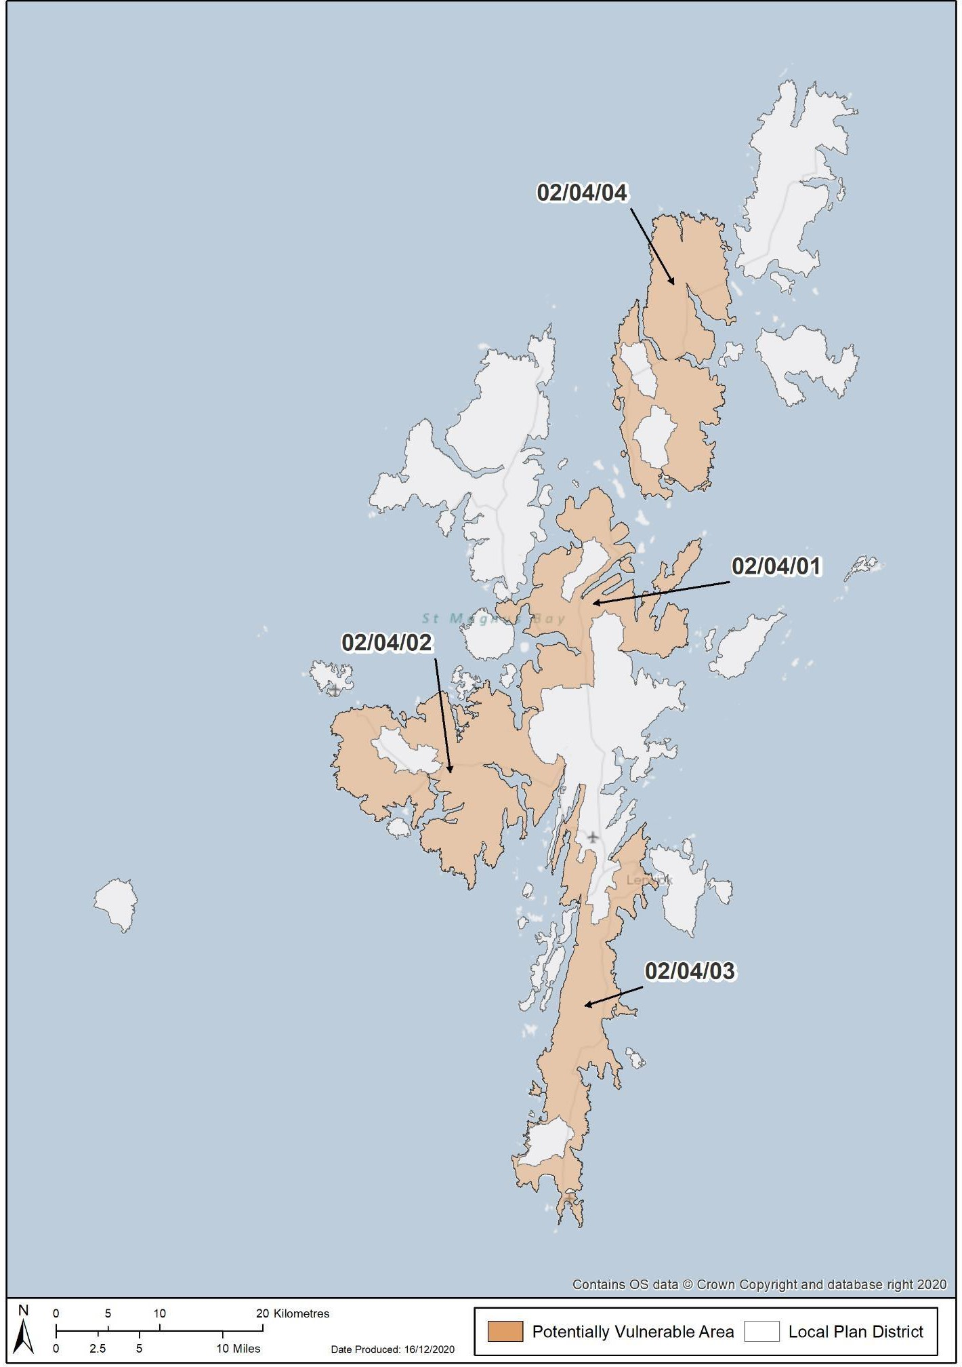

**Figure 1. Potentially vulnerable areas in the Shetland Local Plan District**

## LPD 4 Shetland – List of PVAs

*Click the blue text to select your area of interest*

|  |  |  |  |
| --- | --- | --- | --- |
| **PVA Ref** | **PVA Name** | **Local authority area** | **Page number** |
| 02/04/01 | Shetland North Mainland | Shetland | 34 |
| 02/04/02 | Shetland West Mainland | Shetland | 37 |
| 02/04/03 | Shetland Central and South Mainland | Shetland | 40 |
| 02/04/04 | Yell | Shetland | 47 |

## 02/04/01 (Shetland North Mainland)

This area is designated as a potentially vulnerable area due to the risk of coastal flooding in Vidlin. Coastal flood risk is likely to increase due to sea level rise caused by climate change.

There is 1 target area in this potentially vulnerable area, which has been the focus of further assessment, this is identified below. Further information on the objectives and actions to manage flood risk within this area is provided below.

#### List of target areas

Vidlin (target area 369)

# Flood risk management plan datasheet

#### Vidlin (target area 369)

**Summary Location map**

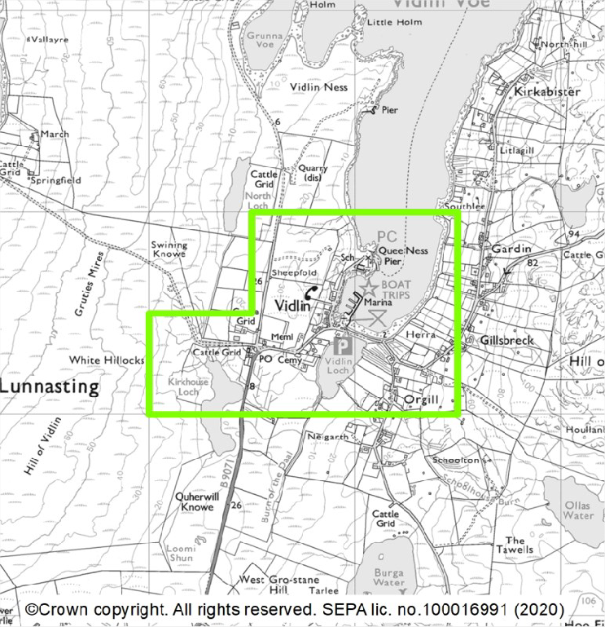

Vidlin is located along the western shore of Vidlin Voe, on Mainland Shetland in the Shetland Islands Council area. The main source of flooding to Vidlin is coastal flooding. A local assessment indicates that few properties are currently at risk of flooding. However, the number of properties at risk is expected to increase due to the impacts of climate change on sea level rise. There is concern of sea level rise affecting flood risk to the Vidlin causeway.

**What is the current understanding of flood risk?**

This section provides a summary of information, which has helped to develop an understanding of flood risk in the area. Since 2011 SEPA has developed and updated national level assessments of flooding from rivers, surface water and coastal sources. The national level assessment is improved for coastal flooding through a flood study in Vidlin. This included an aerial drone survey to assess the local topography as the area has not yet been covered by national LIDAR surveying. The impacts of climate change on future sea levels were also assessed based on the latest data (United Kingdom Climate Projections 2018). There are no records of flooding in the Vidlin target area but this does not confirm that there is no flood risk. The primary concern is breaking waves and spray running over the causeway. This would significantly affect pedestrian use. This may occur more frequently in the future due to the impacts of climate change on sea level rise.

#### What are the objectives for the area?

In each target area, SEPA and the responsible authorities have set objectives for the management of flood risk. In some locations, the objectives provide a short-term direction that will be reviewed and updated when more information is available. In others they provide a long-term direction for the management of flooding within a community. The objectives along with the current understanding of flood risk help to identify the actions that are required in the short and long term. It may take several years or multiple 6 year cycles to achieve the identified objectives, but they set a common goal for multiple agencies.

The following package of objectives have been established for this area. The objectives must be considered alongside national principles to manage flood risk. These include:

* Take a long term, risk-based approach to flood risk management decisions and one that considers the impacts of and adaptability to climate change.
* Deliver coordinated and integrated flood risk management by engaging with communities and working in

partnership, sharing data, expertise, services, and resources.

* Consider whole catchments and coastlines and work with natural processes and the environment to deliver

|  |  |  |
| --- | --- | --- |
| **Objective ref** | **Objective type** | **Objective Description** |
| 3691 | Avoid flood risk | Avoid inappropriate development that increases flood risk  in Vidlin. |
| 3692 | Improve data and understanding | Improve data and understanding of the risk of coastal  flooding resulting from climate change to the Vidlin causeway. |
| 3693 | Prepare for flooding | Prepare for current flood risk and future flooding as a result  of climate change in Vidlin. |

#### What actions are proposed for this area?

As outlined in Section 1 of this plan, at the date of publication the actions below represent the best understanding of what is needed to work towards the objectives for the area. They have been developed with the other responsible authorities and take account of progress achieved to date, the understanding of flood risk and the objectives set for the area. The local flood risk management plan published in 2022 provides more information on the actions, their timing and how they will be funded and coordinated.

|  |  |
| --- | --- |
| **Actions proposed to start between 2022 and 2028**  **Flood study (Ref: 36901)** | |
| **Action**  **Description** | An understanding of flood risk and associated issues in the area is to be developed, which may include surveys and modelling and should consider the impacts of climate change on flood risk. In areas where flood risk is confirmed, a range of possible options to manage flood risk are to be identified, including natural flood management actions where suitable, and a preferred approach is to be chosen. This should include adaptive planning to allow for the impacts of climate change to be monitored, understood and managed. |
| A flood study is needed to assess future still water flood levels relative to the causeway. Climate change is expected to cause rising sea levels and changes to storm patterns. This could lead to flooding happening more often. It is important to plan for this and ensure future risk to communities and infrastructure is managed  appropriately. The need for an adaptation plan should be assessed. |

SEPA and responsible authorities carry out actions in all areas which help to manage current and future flooding. These actions help to ensure that key aspects of flood risk management are taken forward in all locations. They ensure that for example new housing developments occur in the right places, and that critical flood risk information is developed and updated for all areas. A description of these actions is included in the Local Plan District section at the start of this document.

## 02/04/02 (Shetland West Mainland)

This area is designated as a potentially vulnerable area due to coastal flood risk to Walls. Coastal flood risk is likely to increase due to sea level rise caused by climate change.

There is 1 target area in this potentially vulnerable area, which has been the focus of further assessment, this is identified below. Further information on the objectives and actions to manage flood risk within this area is provided below.

#### List of target areas

Walls (target area 368)

# Flood risk management plan datasheet

#### Walls (target area 368)

**Summary Location map**

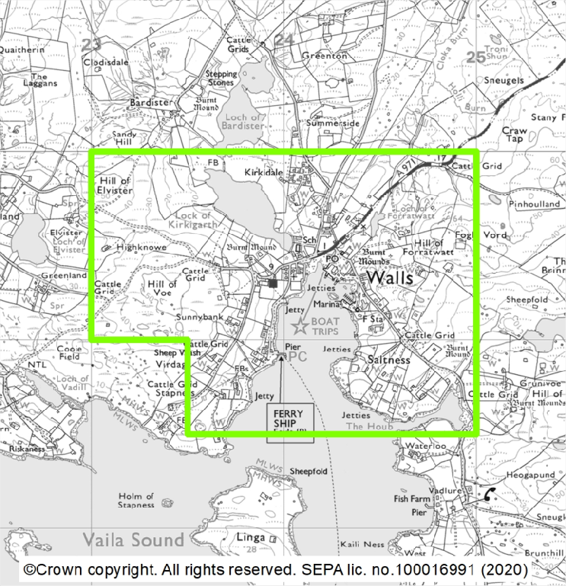

Walls is located on the west side of Mainland Shetland in the Shetland Islands Council area. The main source of flooding in Walls is coastal flooding. A local assessment indicates that few properties are currently at risk of flooding however, the number of properties at risk is expected to increase significantly due to the impacts of climate change on sea level rise.

**What is the current understanding of flood risk?**

This section provides a summary of information, which has helped to develop an understanding of flood risk in the area. Since 2011 SEPA has developed and updated national level assessments of flooding from rivers, surface water and coastal sources. The national level assessment is improved for coastal flooding through a flood study in Walls. This included an aerial drone survey to assess the local topography as the area has not yet been covered by national LIDAR surveying. The impacts of climate change on future sea levels were also assessed based on the latest data (United Kingdom Climate Projections 2018). There are limited records of flooding in Walls.

#### What are the objectives for the area?

In each target area, SEPA and the responsible authorities have set objectives for the management of flood risk. In some locations, the objectives provide a short-term direction that will be reviewed and updated when more information is available. In others they provide a long-term direction for the management of flooding within a community. The objectives along with the current understanding of flood risk help to identify the actions that are required in the short and long term. It may take several years or multiple 6 year cycles to achieve the identified objectives, but they set a common goal for multiple agencies.

The following package of objectives have been established for this area. The objectives must be considered alongside national principles to manage flood risk. These include:

* Take a long term, risk-based approach to flood risk management decisions and one that considers the impacts of and adaptability to climate change.
* Deliver coordinated and integrated flood risk management by engaging with communities and working in

partnership, sharing data, expertise, services, and resources.

* Consider whole catchments and coastlines and work with natural processes and the environment to deliver

multiple outcomes.

|  |  |  |
| --- | --- | --- |
| **Objective ref** | **Objective type** | **Objective Description** |
| 3681 | Avoid flood risk | Avoid inappropriate development that increases flood risk  in Walls. |
| 3682 | Prepare for flooding | Prepare for current flood risk and future flooding as a result  of climate change in Walls. |

#### What actions are proposed for this area?

As outlined in Section 1 of this plan, at the date of publication the actions below represent the best understanding of what is needed to work towards the objectives for the area. They have been developed with the other responsible authorities and take account of progress achieved to date, the understanding of flood risk and the objectives set for the area. The local flood risk management plan published in 2022 provides more information on the actions, their timing and how they will be funded and coordinated.

|  |  |
| --- | --- |
| **Actions proposed to start between 2022 and 2028**  **Adaptation plan (Ref: 36801)** | |
| **Action Description** | Information on climate change is to be used to develop an adaptation plan to allow for the impacts of climate change to be monitored, understood and managed. |
| Based on Shetland Island Council’s flood study, an adaptation plan should be  developed. Climate change is expected to cause rising sea levels and changes to storm patterns. This could lead to flooding happening more often. It is important to plan for this and ensure future risk to communities and infrastructure is managed appropriately. |

SEPA and responsible authorities carry out actions in all areas which help to manage current and future flooding. These actions help to ensure that key aspects of flood risk management are taken forward in all locations. They ensure that for example new housing developments occur in the right places, and that critical flood risk information is developed and updated for all areas. A description of these actions is included in the Local Plan District section at the start of this document.

## 02/04/03 (Shetland Central and South Mainland)

This area is designated as a potentially vulnerable area due to the risk of flooding from small rivers and surface water to Cunningsburgh, Lerwick and Scalloway.

There are 3 target areas in this potentially vulnerable area, which have been the focus of further assessment, these are listed below. Further information on the objectives and actions to manage flood risk within this area is provided below.

#### List of target areas

Lerwick (target area 383)

Scalloway (target area 442)

Cunningsburgh (target area 448)

# Flood risk management plan datasheet

#### Lerwick (target area 383)

**Summary Location map**

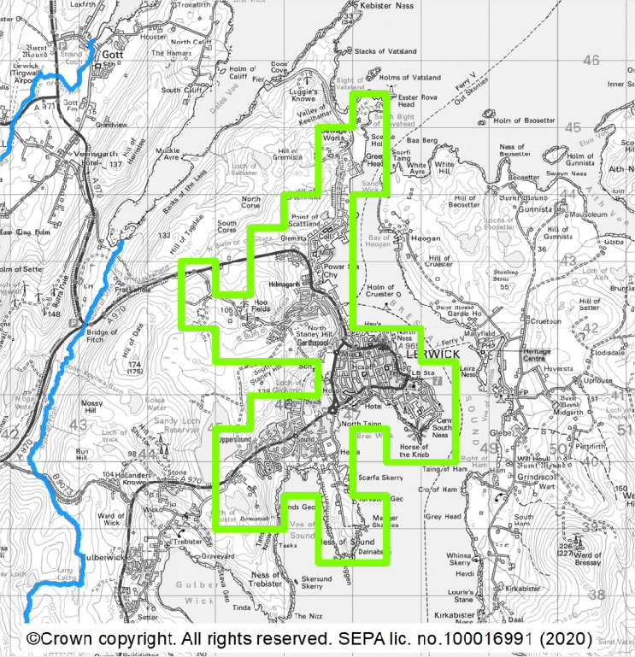

Lerwick is the main town within the Shetland Islands Council area. The main source of flooding in Lerwick is surface water. There are approximately 50 people and 70 homes and businesses currently at risk from flooding. This is likely to increase to 60 people and 70 homes and businesses by the 2080s due to climate change.

**What is the current understanding of flood risk?**

This section provides a summary of information, which has helped to develop an understanding of flood risk in the area. Since 2011 SEPA has developed and updated national level assessments of flooding from rivers, surface water and coastal sources. The national level assessment is improved for surface water through the development of a surface water management plan for Lerwick and the completion of a sewer flood risk assessment. There are periodic records of flooding in Lerwick. A recent flood in November 2020 was caused by surface water following persistent rainfall. There are also records of coastal flooding around the harbour areas.

#### What are the objectives for the area?

In each target area, SEPA and the responsible authorities have set objectives for the management of flood risk. In some locations, the objectives provide a short-term direction that will be reviewed and updated when more information is available. In others they provide a long-term direction for the management of flooding within a community. The objectives along with the current understanding of flood risk help to identify the actions that are required in the short and long term. It may take several years or multiple 6 year cycles to achieve the identified objectives, but they set a common goal for multiple agencies.

The following package of objectives have been established for this area. The objectives must be considered alongside national principles to manage flood risk. These include:

* Take a long term, risk-based approach to flood risk management decisions and one that considers the impacts of and adaptability to climate change.
* Deliver coordinated and integrated flood risk management by engaging with communities and working in

partnership, sharing data, expertise, services, and resources.

* Consider whole catchments and coastlines and work with natural processes and the environment to deliver

multiple outcomes.

|  |  |  |
| --- | --- | --- |
| **Objective ref** | **Objective type** | **Objective Description** |
| 3831 | Avoid flood risk | Avoid inappropriate development that increases flood risk  in Lerwick. |
| 3832 | Prepare for flooding | Prepare for current flood risk and future flooding as a result  of climate change in Lerwick. |
| 3833 | Reduce flood risk | Reduce the risk of surface water flooding in Lerwick. |

#### What actions are proposed for this area?

As outlined in Section 1 of this plan, at the date of publication the actions below represent the best understanding of what is needed to work towards the objectives for the area. They have been developed with the other responsible authorities and take account of progress achieved to date, the understanding of flood risk and the objectives set for the area. The local flood risk management plan published in 2022 provides more information on the actions, their timing and how they will be funded and coordinated.

|  |  |
| --- | --- |
| **Actions proposed to start between 2022 and 2028**  **Surface water management plan (Ref: 38301)** | |
| **Action**  **Description** | Areas at risk of heavy or prolonged rainfall causing flooding due to water ponding on man-made surfaces or overwhelming the drainage system have been identified. Next steps in managing such water ponding or over-whelmed drainage systems  have been identified and should be implemented. The plan is to be reviewed and updated as needed. |
| The local flood risk management plans published in December 2022 will establish  further detail on the actions. |

SEPA and responsible authorities carry out actions in all areas which help to manage current and future flooding. These actions help to ensure that key aspects of flood risk management are taken forward in all locations. They ensure that for example new housing developments occur in the right places, and that critical flood risk information is developed and updated for all areas. A description of these actions is included in the Local Plan District section at the start of this document.

# Flood risk management plan datasheet

#### Scalloway (target area 442)

**Summary Location map**

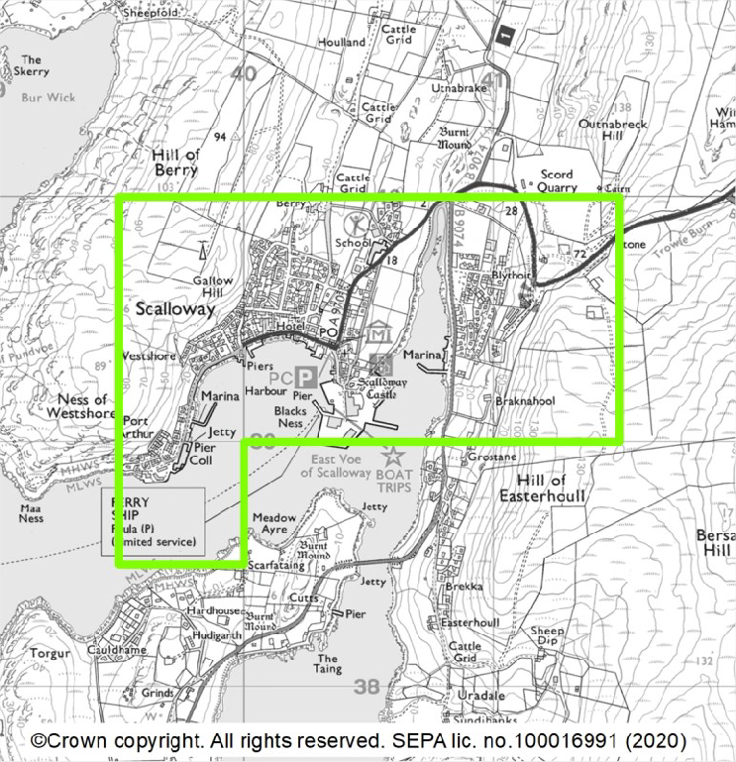

Scalloway is on the west coast of Mainland, the largest of the Shetland Islands and is in the Shetland Islands Council area. The main source of flooding in Scalloway is from surface water and small water courses. This is worsened when the water cannot drain into the sea at high tide. There is also a risk of coastal flooding, which is underestimated in the flood maps. There are approximately 20 people and 10 homes and businesses at risk from flooding. The effects of climate change on sea level risk and the drainage system are likely underestimated.

**What is the current understanding of flood risk?**

This section provides a summary of information, which has helped to develop an understanding of flood risk in the area. Since 2011 SEPA has developed and updated national level assessments of flooding from rivers, surface water and coastal sources. The national level assessment is improved through the development of a surface water management plan for Scalloway. This is linked to the Scalloway Place Plan which considered future waterfront development and flood risk issues. A sewer flood risk assessment has also been completed. There are recent records of periodic flooding in Scalloway. This include notable surface water and river flooding in August 2012. The flooding was exacerbated when the high tide blocked the outflow of the burn.

#### What are the objectives for the area?

In each target area, SEPA and the responsible authorities have set objectives for the management of flood risk. In some locations, the objectives provide a short-term direction that will be reviewed and updated when more information is available. In others they provide a long-term direction for the management of flooding within a community. The objectives along with the current understanding of flood risk help to identify the actions that are required in the short and long term. It may take several years or multiple 6 year cycles to achieve the identified objectives, but they set a common goal for multiple agencies.

The following package of objectives have been established for this area. The objectives must be considered alongside national principles to manage flood risk. These include:

* Take a long term, risk-based approach to flood risk management decisions and one that considers the impacts of and adaptability to climate change.
* Deliver coordinated and integrated flood risk management by engaging with communities and working in

partnership, sharing data, expertise, services, and resources.

* Consider whole catchments and coastlines and work with natural processes and the environment to deliver

multiple outcomes.

|  |  |  |
| --- | --- | --- |
| **Objective ref** | **Objective type** | **Objective Description** |
| 4421 | Avoid flood risk | Avoid inappropriate development that increases flood risk  in Scalloway. |
| 4422 | Prepare for flooding | Prepare for current flood risk and future flooding as a result  of climate change in Scalloway. |
| 4423 | Prepare for flooding | Develop an adaptive approach for Scalloway seafront to  future coastal flooding resulting from climate change. |
| 4424 | Reduce flood risk | Reduce the risk of flooding from surface water and small  water courses in Scalloway. |

#### What actions are proposed for this area?

As outlined in Section 1 of this plan, at the date of publication the actions below represent the best understanding of what is needed to work towards the objectives for the area. They have been developed with the other responsible authorities and take account of progress achieved to date, the understanding of flood risk and the objectives set for the area. The local flood risk management plan published in 2022 provides more information on the actions, their timing and how they will be funded and coordinated.

|  |  |
| --- | --- |
| **Actions proposed to start between 2022 and 2028**  **Surface water management plan (Ref: 44201)** | |
| **Action**  **Description** | Areas at risk of heavy or prolonged rainfall causing flooding due to water ponding on man-made surfaces or overwhelming the drainage system have been identified. Next steps in managing such water ponding or over-whelmed drainage systems have been identified and should be implemented. The plan is to be reviewed and updated as needed. |
| The Scalloway Surface Water Management Plan should be implemented. This should be coordinated with the Scalloway Local Place Plan and the shoreline management plan. The impacts of climate change on flood risk, including tidal locking due to rising sea levels, should be considered. The need for an adaptation plan should be assessed. The potential short term action of providing an overflow culvert to the burn at Burn Beach would also need to be considered in relation to  other possible works that have arisen in the place plan, and their funding and timescales. |
| **Shoreline management plan (coastal adaptive plan) (Ref: 44202)** | |
| **Action**  **Description** | An assessment of coastal flood and erosion risk is to be carried out. The plan should include assessment of climate change and develop adaptive approaches to allow for the impacts of climate change to be monitored, understood and managed. |
| A shoreline management plan should be developed. This should review the existing defences. This should also be integrated with the surface water management plan and Scalloway Local Place Plan. The impacts of climate change on sea level rise and flood risk should be considered and the need for an adaptation plan should be  reviewed. |

SEPA and responsible authorities carry out actions in all areas which help to manage current and future flooding. These actions help to ensure that key aspects of flood risk management are taken forward in all locations. They ensure that for example new housing developments occur in the right places, and that critical flood risk information is developed and updated for all areas. A description of these actions is included in the Local Plan District section at the start of this document.

# Flood risk management plan datasheet

#### Cunningsburgh (target area 448)

**Summary Location map**

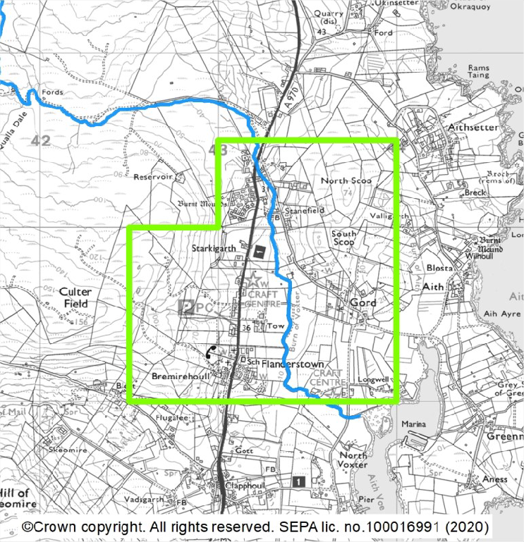

Cunningsburgh is on Mainland, within the Shetland Islands Council area. The primary source of flooding is from the Burn of Voxter. Flooding can affect the road that connects Lerwick to Sumburgh airport. There are less than 10 people and homes currently at risk from flooding. This is estimated to remain the same by the 2080s despite the effect of climate change.

**What is the current understanding of flood risk?**

This section provides a summary of information, which has helped to develop an understanding of flood risk in the area. Since 2011 SEPA has developed and updated national level assessments of flooding from rivers, surface water and coastal sources. The national level assessment is improved for flooding from the Burn of Voxter due to the Cunningsburgh flood study. There are limited records of flooding in the Cunningsburgh area. The floods that have been recorded in this area are associated with flooding from the Burn of Voxter.

#### What are the objectives for the area?

In each target area, SEPA and the responsible authorities have set objectives for the management of flood risk. In some locations, the objectives provide a short-term direction that will be reviewed and updated when more information is available. In others they provide a long-term direction for the management of flooding within a community. The objectives along with the current understanding of flood risk help to identify the actions that are required in the short and long term. It may take several years or multiple 6 year cycles to achieve the identified objectives, but they set a common goal for multiple agencies.

The following package of objectives have been established for this area. The objectives must be considered alongside national principles to manage flood risk. These include:

* Take a long term, risk-based approach to flood risk management decisions and one that considers the impacts of and adaptability to climate change.
* Deliver coordinated and integrated flood risk management by engaging with communities and working in

partnership, sharing data, expertise, services, and resources.

* Consider whole catchments and coastlines and work with natural processes and the environment to deliver

multiple outcomes.

|  |  |  |
| --- | --- | --- |
| **Objective ref** | **Objective type** | **Objective Description** |
| 4481 | Avoid flood risk | Avoid inappropriate development that increases flood risk  in Cunningsburgh. |
| 4482 | Prepare for flooding | Prepare for current flood risk and future flooding as a result  of climate change in Cunningsburgh. |
| 4483 | Reduce flood risk | Reduce the risk of flooding from the Burn of Laxdale to  Cunningsburgh and the road connecting Lerwick to Sumburgh. |

#### What actions are proposed for this area?

As outlined in Section 1 of this plan, at the date of publication the actions below represent the best understanding of what is needed to work towards the objectives for the area. They have been developed with the other responsible authorities and take account of progress achieved to date, the understanding of flood risk and the objectives set for the area. The local flood risk management plan published in 2022 provides more information on the actions, their timing and how they will be funded and coordinated.

|  |  |
| --- | --- |
| **Actions proposed to start between 2022 and 2028**  **Flood scheme or works implementation (Ref: 44801)** | |
| **Action**  **Description** | The flood scheme/works is to be built following agreement of the design, costs and timescales. |
| Progress design options to reduce flood risk in the area of the culvert on the A970  which transports the Burn of Voxter under the road. |

SEPA and responsible authorities carry out actions in all areas which help to manage current and future flooding. These actions help to ensure that key aspects of flood risk management are taken forward in all locations. They ensure that for example new housing developments occur in the right places, and that critical flood risk information is developed and updated for all areas. A description of these actions is included in the Local Plan District section at the start of this document.

## 02/04/04 (Yell)

This area is designated as a potentially vulnerable area due to the risk of coastal flooding to the main access road to the ferry terminal in Yell. Coastal flood risk is likely to increase due to sea level rise caused by climate change. Recent flooding was a result of coastal flooding.

There is 1 target area in this potentially vulnerable area, which has been the focus of further assessment, this is identified below. Further information on the objectives and actions to manage flood risk within this area is provided below.

#### List of target areas

Cullivoe (target area 388)

# Flood risk management plan datasheet

#### Cullivoe (target area 388)

**Summary Location map**

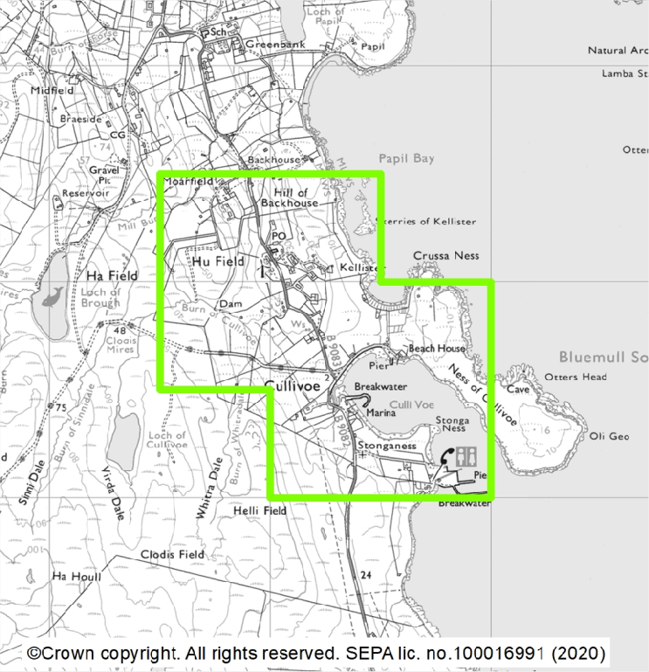

Cullivoe is located along the east coast of Yell and is within the Shetland Islands Council area. The only significant source of flooding in Cullivoe is coastal flooding. Coastal flooding affects road access to the south, the only road link to the rest of the island.

There are less than 10 people, homes and businesses currently at risk from flooding. This is likely to remain the same by 2080s irrespective of climate change although frequency of disruption to road access is likely to increase.

**What is the current understanding of flood risk?**

This section provides a summary of information, which has helped to develop an understanding of flood risk in the area. Since 2011 SEPA has developed and updated national level assessments of flooding from rivers, surface water and coastal sources, and this national assessment has highlighted the risk of coastal flooding affecting the road to the ferry terminal and therefore access and egress to the island. The flooding to the road may occur more frequently in the future due to climate change. Cullivoe has therefore been identified as a new target area for the 2021 flood risk management plans. The national level assessment is improved for coastal flooding through the work around the design of a bridge replacement scheme which also increases the level of the road on its coastal lengths. Local reports indicate frequent road flooding in Cullivoe.

#### What are the objectives for the area?

In each target area, SEPA and the responsible authorities have set objectives for the management of flood risk. In some locations, the objectives provide a short-term direction that will be reviewed and updated when more information is available. In others they provide a long-term direction for the management of flooding within a community. The objectives along with the current understanding of flood risk help to identify the actions that are required in the short and long term. It may take several years or multiple 6 year cycles to achieve the identified objectives, but they set a common goal for multiple agencies.

The following package of objectives have been established for this area. The objectives must be considered alongside national principles to manage flood risk. These include:

* Take a long term, risk-based approach to flood risk management decisions and one that considers the impacts of and adaptability to climate change.
* Deliver coordinated and integrated flood risk management by engaging with communities and working in

partnership, sharing data, expertise, services, and resources.

* Consider whole catchments and coastlines and work with natural processes and the environment to deliver

multiple outcomes.

|  |  |  |
| --- | --- | --- |
| **Objective ref** | **Objective type** | **Objective Description** |
| 3881 | Prepare for flooding | Prepare for current flood risk and future flooding as a result  of climate change in Cullivoe. |
| 3882 | Prepare for flooding | Develop an adaptive approach for coastal flooding resulting  from climate change to the B9082 to the ferry terminal. |

#### What actions are proposed for this area?

As outlined in Section 1 of this plan, at the date of publication the actions below represent the best understanding of what is needed to work towards the objectives for the area. They have been developed with the other responsible authorities and take account of progress achieved to date, the understanding of flood risk and the objectives set for the area. The local flood risk management plan published in 2022 provides more information on the actions, their timing and how they will be funded and coordinated.

|  |  |
| --- | --- |
| **Actions proposed to start between 2022 and 2028**  **Flood scheme or works design (Ref: 38801)** | |
| **Action**  **Description** | The selected preferred approach for managing flood risk is to be designed following the completion of the flood study, including consideration of the long-term impacts of climate change. These can include small scale works or works to improve catchment management. This should guide adaptive planning to allow for  the impacts of climate change to be monitored, understood and managed. |
| Progress the proposed design for the bridge replacement and road raising. The levels meet the 1 in 200 year (0.5% annual exceeedance probability) standard of protection plus climate change.  In accordance with the flood risk management plan, as part of the scheme or works, the responsible authority should aim to ensure that the action will not have an adverse effect on the integrity of the Bluemull and Colgrave Sounds Special Protection Area. |
| **Flood scheme or works implementation (Ref: 38802)** | |
| **Action**  **Description** | The flood scheme/works is to be built following agreement of the design, costs and timescales. |
| Once detailed design is complete, the bridge replacement and road raising should  be progressed. |
| **Community engagement (Ref: 38803)** | |
| **Action**  **Description** | Community engagement is to continue to be carried out in the area by the responsible authorities to raise awareness of flood risk. |
| The responsible authorities to continue to engage with the community, with  particular focus on the bridge replacement and road raising works. |
| **Property flood resilience scheme (Ref: 38804)** | |
| **Action**  **Description** | The proposed scheme to provide resilience measures against flooding for individual buildings is to be taken forward to help prevent water entering the property and to minimise flood damage. |
| Any residual flood risk after the works have been completed may be managed with  property flood resilience. |

SEPA and responsible authorities carry out actions in all areas which help to manage current and future flooding. These actions help to ensure that key aspects of flood risk management are taken forward in all locations. They ensure that for example new housing developments occur in the right places, and that critical flood risk information is developed and updated for all areas. A description of these actions is included in the Local Plan District section at the start of this document.

### Annex 1: Costs of actions

|  |  |  |
| --- | --- | --- |
| **Action** | **Indicative**  **capital cost (£)** | **Notes** |
| Adaptation plan | 30,000 | Costs can vary greatly depending on the scale and complexity of flooding |
| Data collection | 20,000 |
| Flood scheme or works design | 300,000 | Costs can vary greatly depending on the scale and complexity of flooding, along with the ground conditions |
| Flood study | 50,000 | Costs can vary greatly depending on the scale and complexity of flooding |
| Flood study (existing flood  defences) | 80,000 |
| Flood study (options appraisal) | 40,000 |
| Shoreline Management Plan  (Coastal Adaptive Plan) | 100,000 |
| Surface water management  plan | 30,000 |
| Flood scheme or works  implementation | N/A | Schemes are very individual and it is not  possible to provide an indicative cost. |
| **The costs involved in the following actions are predominately from staff resource:** | | |
| Community engagement | N/A | Resources required are very specific for the individual action. It is currently not possible to estimate a resource cost. |
| Community flood alert | N/A |
| Community resilience group | N/A |
| Emergency plan | N/A |
| Flood defence maintenance | N/A | Cost of maintenance is specific to the defence and is impacted by among other things age and type of the defences. It is not  possible to provide indicative costs. |
| Flood risk management review | N/A | Resources required are very specific for the individual action. It is currently not possible to estimate a resource cost. |
| Flood warning maintenance | N/A |
| Flood warning scoping | N/A |
| Land Use Planning | N/A |
| Maintain flood protection  scheme | N/A |
| New flood warning area | N/A |
| Property flood resilience  scheme | N/A |
| Sewer flood risk assessment | N/A |
| Site protection plan | N/A |
| Strategic mapping improvements | N/A |

**Annex 2: Flood risk management plans consultation summary**

Asking for and listening to input from stakeholders and the public is a key part of flood risk management in Scotland. SEPA and the local authorities undertook a joint consultation, which ran in 2 phases between December 2020 and October 2021. Phase 1, opened in December 2020 and included a summary of flooding in each Local Plan District, a description of the potentially vulnerable areas and the identified local target areas. Phase 2 opened for responses on 30th July 2021 and closed on 31st October 2021. Phase 2 identified the objectives for each target area and the actions needed to achieve these objectives. It also included prioritisation of the actions by 6 year cycle. Local authorities provided more detail in the draft local flood risk management plans, which included an expanded description of the actions, and who would lead and coordinate delivery.

The consultation was open to everyone with an interest in flood risk management.

The communications campaign to publicise the consultation aimed to encourage anyone with an interest in flooding to have their say on how flood risk is managed across Scotland.

Communication activities included:

* A public notice in the Edinburgh Gazette and The Herald
* A national press release
* Social media posts on Facebook, Twitter, LinkedIn, Instagram
* A national targeted, paid social media campaign on Facebook, Twitter, and Instagram.

An animation and graphics were created to promote the consultation. These were shared with all responsible authorities in advance of the consultation and were regularly publicised via social media. The consultation was picked up by many local media outlets including local newspapers.

SEPA staff also supported several national events aimed at raising awareness of the consultation.

Demonstration of the consultation platform was provided to ensure that stakeholders were able to navigate the Citizen Space platform and answer the consultation questions.

Local authority flooding teams were provided with briefing packs with access to draft article templates and social media messages which they could use to promote the consultation within their own organisation and local area. Many local authorities used their network of community councils to promote the consultation.

In total SEPA received 677 responses. These included 654 online responses via the consultation platform Citizen Space and 23 e-mail responses received via SEPA’s consultation mailbox. Compared to the first consultation on the flood risk management strategies in 2014, there has been a welcome three-fold increase in the number of responses. The majority of the responses (520) were from members of the public. This reflects increased public awareness of flooding and flood risk management, and the increasing risk due to climate change.

SEPA is grateful to individuals and organisations for considering the proposals and providing feedback. Responses varied from detailed comments on the actions proposed in individual target areas, to general comments on flooding and flood risk management. The sections below provide a brief outline of the responses received and changes made as a result.

Many of the aspects raised relate to the underlying requirements of the Flood Risk Management (Scotland) 2009 Act, to activities which are the responsibility of other organisations, or to the content of the local flood risk management plans. Working within safe data sharing practices, SEPA will ensure the feedback received is passed to other responsible authorities to consider and act on.

This summary is a factual statement of the responses provided. All responses received have been read and considered, resulting in a number of changes to the plans. Further detail on the analysis of responses will be published by SEPA in Spring 2022.

#### Identifying communities and infrastructure at risk

In the consultation SEPA asked whether all the main communities and infrastructure at significant risk of flooding were identified. 45% of respondents agreed that the main communities and infrastructure were identified and 29% stated they were not sure. 21% of respondents felt that some communities were missing from the plans.

Some respondents who had recently flooded were concerned that their communities were not identified as target areas. Some respondents suggested additional areas for SEPA to consider where flooding has occurred in the past. Concerns were also expressed about the method used to identify the main communities at risk.

#### Proposed objectives

34% of respondents supported the proposals for objectives to manage flood risk in target areas and 30% were not sure. 25% did not agree and 10% did not answer this question.

The main concerns of those who did not agree with the proposed objectives were that timescales were long-term and would not result in immediate action, objectives did not cover wider issues such as sewerage flooding, objectives were not detailed enough, and that objectives did not limit new development. There were concerns that there was no evidence being provided to show that the objectives were being met by the authorities, and that objectives were not leading to actions on the ground.

#### Proposed actions to manage flood risk

43% of respondents were not sure whether the actions would work towards achieving the objectives. 25% of respondents did not agree with the proposed actions to manage flood risk. 20% agreed with the proposed actions and 12% did not answer this question.

Those who did not agree expressed concerns that flood studies were not resulting in actions on the ground, that actions were not detailed enough, some stressed the need for other actions such as drain clearance being done now and some emphasised the need for a catchment-based approach and natural flood management.

Others asked for more watercourse clearing and river management and more transparency from the local authority in publicising the maintenance plan for flood defences. Concerns were also expressed that new development is not being controlled and is contributing to increased surface water flooding and that there were no actions to address sewerage flooding. Concerns were also raised about funding for actions.

NatureScot provided feedback on specific target areas and the impacts on biodiversity and designated sites.

#### Timescales for implementing actions

In terms of the proposed timescales, 36% of respondents did not agree and 32% were not sure of the identified timescales. 17% agreed and 15% did not respond to this question.

Those who disagreed were concerned that actions were taking too long and that more urgent action is needed in light of climate change. Respondents also commented that timescales were too vague and should be more detailed.

#### What can individuals, communities and organisations do to help manage flood risk?

SEPA also asked whether individuals, communities or organisations were able to help with flood risk management in Scotland. There was a range of responses to this question, with 39% of respondents agreeing that there is something they could do to help manage flood risk and 26% of respondents not sure that there are things they could do.

Those who were not sure asked for more guidance from the authorities. However, many felt that there was something that communities or individuals can do.

Suggestions included less paving of gardens to help attenuate rainwater, authorities developing information to help the public make more informed decisions, community organised clearance of watercourses where it is safe to do so, reporting blockages and flooding to the authorities, planting trees and greening of cities.

#### Acting on consultation feedback

Several changes were made to the final flood risk management plans as a result of the input received during the consultation. A summary of those changes is provided in the table below, and full details will be provided in the consultation digest to be published by SEPA in Spring 2022.

|  |
| --- |
| **Summary of changes made to the plans following the consultation** |
| **1.** Further actions were added to manage flood risk in several target areas. |
| **2.** Additional Local Plan District actions were added. |
| **3.** Some actions were removed from the flood risk management plans at the  request of local authorities responsible for their delivery due to completion in the time between consultation and publication. |
| **4.** Further information was included on how climate change was assessed in the  preparation of the plans. |
| **5.** Further information was included on how potentially vulnerable areas were  identified, and when they will be reviewed again. |
| **6.** Information was included on the progress made in implementing actions and  working towards objectives in the 2015 strategies. |
| **7.** A target area boundary was amended based on new information provided. |
| **8.** A description of the importance of community actions, recognising the work that communities do to manage flooding was included, along with further information  on where support is available to help people reduce their own flood risk. |
| **9.** A description of the catchment-based approach SEPA has taken, and the role it  plays in delivering flood risk management actions was provided. |
| **10.** The link between flood risk management plans and land use planning was  clarified. |
| **11.** Habitats Regulations Appraisal statements were added to each relevant action. |
| **12.** Some other changes were made to the way information is presented to try to  make it clearer e.g., on the timing of actions being carried out. |
| **13.** Further information was provided on the uncertainty associated with funding of  flood risk management actions. |

**Annex 3: Acknowledgements**

SEPA acknowledges the cooperation and input provided in preparing these plans, including the following:

**Ordnance Survey** Maps are based upon Ordnance Survey material with the permission of Ordnance Survey on behalf of the Controller of Her Majesty’s Stationery Office © Crown Copyright. Any unauthorised reproduction infringes Crown copyright and may lead to prosecution or civil proceedings. SEPA Licence number 100016991 (2020).

**The Centre for Ecology and Hydrology** Some of the plan development is based upon digital spatial data licensed from the Centre for Ecology and Hydrology © NERC (CEH) and third party licensors.

**Local authorities** SEPA acknowledges the provision of flood models and other supporting data and information from local authorities in Scotland and their collaboration in the production of flood risk management information.

**Scottish Water** SEPA acknowledges the inclusion of surface water flooding data generated by Scottish Water in preparation of flood risk information.

**The Flood Hazard Research Centre** Multi-coloured Manual and Multi-coloured Handbook 2016.

All contributors to the **2018 NFRA**, more information on which can be found at <https://www.sepa.org.uk/data-visualisation/nfra2018/>